25.83: a) 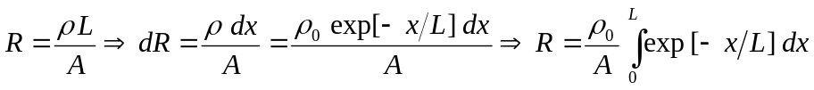
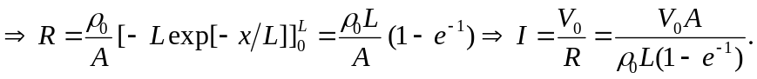
b) 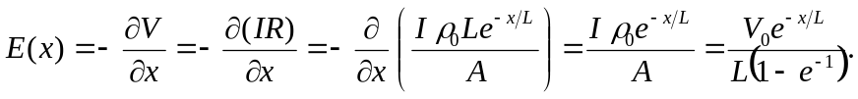
c) 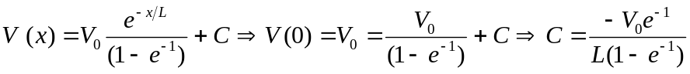
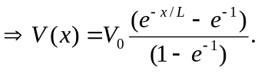
d) Graphs of resistivity, electric field and potential from 